Welcome
Your 2023 Maverick XL has been "Built" and is currently awaiting shipment.


Built
Your vehicle has been built and we are arranging shipment to your dealer. This step could take a few days to a week. Select the "Learn About Your Vehicle" link for information and videos about your new vehicle.
Ford Accessories 
Order Confirmed




09/20/2022
Scheduled Week
Of
06/02/2023
In Production
06/05/2023
Built
06/11/2023
Shipped

Final
Preparation


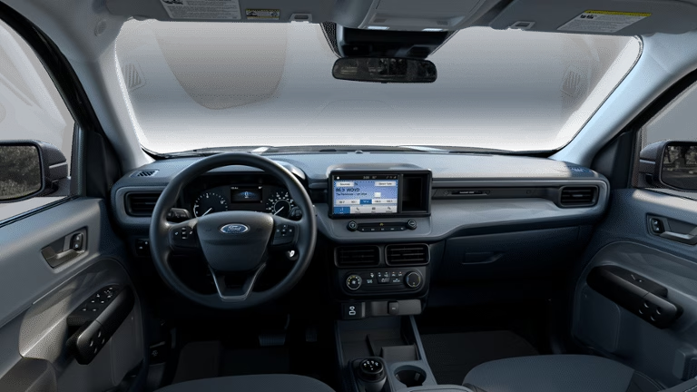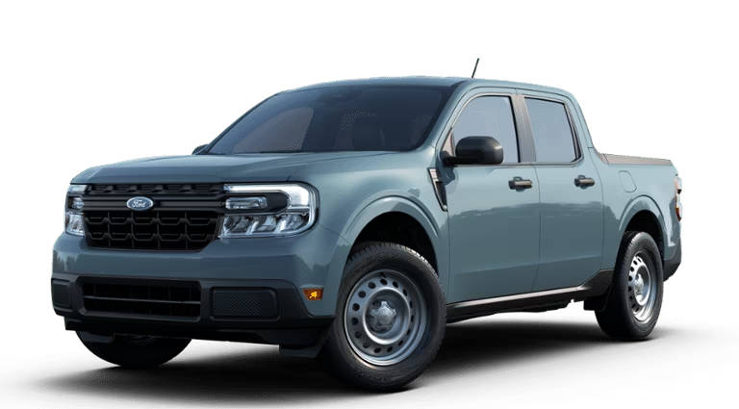
Exterior
Interior
Area 51 Black Onyx / Medium Dark Slate

Vehicle Details
Ordered On 09/20/2022
Order Number
VIN
Last Updated 06/11/2023

Delivery Details
https://www.mikeburchfordofblackshear.com

