- There is a bug in the Ford ECU that will send a mismatched checksum on some hybrid vehicles most commonly when accelerating. This checksum causes and error in the Comma.ai, and the comma will stop controlling the vehicle without warning when this happens. The next step will disable dashcam mode on hybrid fords but does not stop the error from happening. When making this change control may suddenly stop, please be aware you are bypassing Comma safety protocols and are responsible for all results and must be ready to resume control of the car at any time if you complete this procedure.
- Capitalization and indentions are extremely important in the coding sections, so pay attention.
- Create a github.com account.
- Go to https://github.com/sunnyhaibin/sunnypilot
- Create a Fork of the project:
- 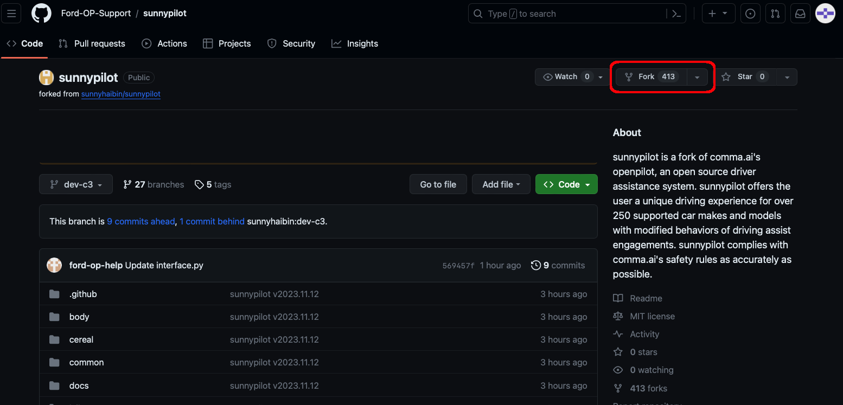
- Setup your fork:
  - choose your username as the owner
  - rename the repository to openpilot
  - be sure to uncheck copy the master branch only:
- 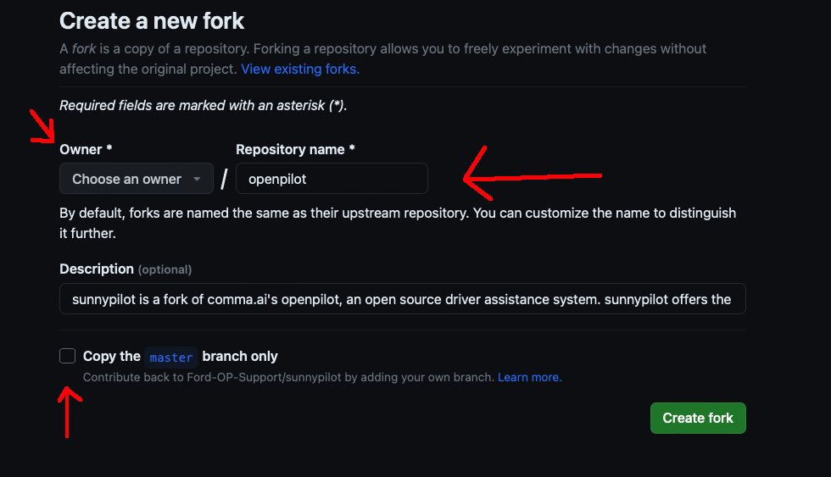
- Once on the home page of your project, choose the branch “dev-c3” from the drop down:
- 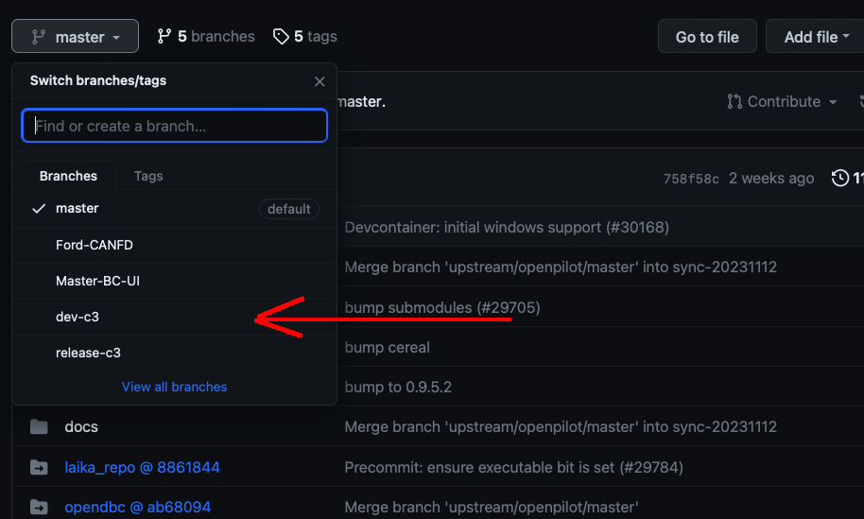
- Browse to selfdrive/car/ford/carstate.py. and click the pencil button to edit:
- Find the line starting with “self.hybrid_platform =”:
- 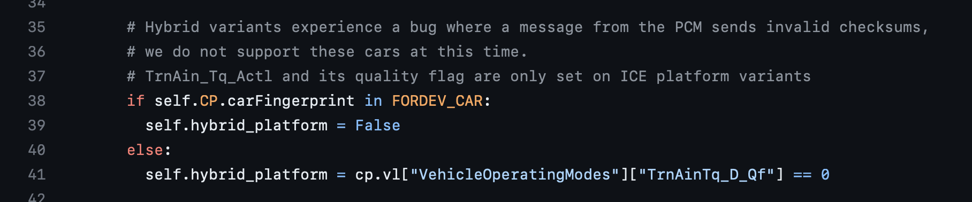
- Replace that line with “self.hybrid_platform = False”
- 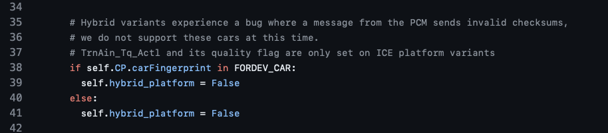
- Click the green commit button in the top right.
- Add a comment to your change so you can remember what you did:
- 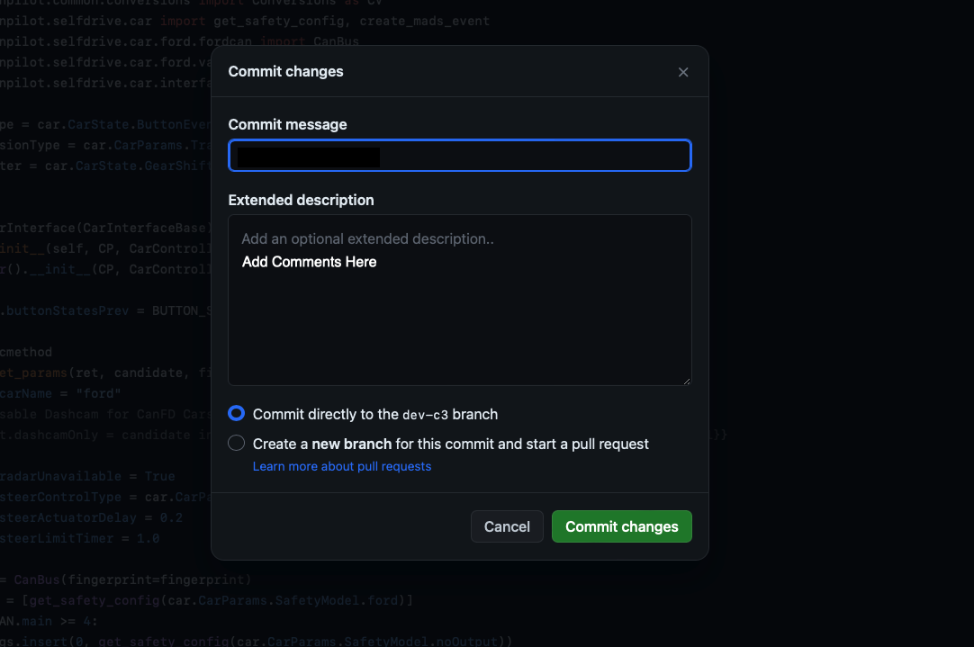
- You should now be able to reinstall openpilot on your comma using the URL: installer.comma.ai/yourusername/dev-c3

